Request for BIDS

TOWN OF RAMAPO
ROCKLAND COUNTY, NEW YORK
Request for Bids

REMOVE AND REPLACE BOILER
AT SENIOR CENTER
TOWN BOARD
MICHAEL SPECHT
SUPERVISOR

BRENDEL CHARLES DAVID WANOUNOU
MICHAEL ROSSMAN YAHUDA WEISMANDL

MICHELLE ANTOSCA
DIRECTOR OF PARKS AND RECREATION
MONA MONTAL
DIRECTOR OF PURCHASING

PART I
1. ADVERTISEMENT

NOTICE TO BIDDERS
FOR
REMOVE AND REPLACE ELEVATOR/LIFT

NOTICE IS HEREBY GIVEN that sealed proposals will be received by the Town Clerk of the Town of Ramapo, at Ramapo Town Hall, 237 Route 59, Suffern, New York 10901, until DECEMBER 8TH, 2021 at 11:30 A.M., at which time and place they will be opened. The proposals shall be for furnishing all materials, equipment, and labor for BID FOR REMOVAL AND REPLACE BOILER AT SENIOR CENTER, 319 HAVERSTRAW ROAD, SUFFERN, NY 10901 in accordance with the specifications and other Contract Documents designated.

Specifications and bid forms may be obtained by visiting “Bidding Opportunities” on the Town of Ramapo web site www.ramapo.org The Town of Ramapo officially distributes bidding documents from the Town Attorney’s Office or through the Hudson Valley Municipal Purchasing Group’s regional bid notification system. Copies of bidding documents obtained from any other source are not considered official copies. Only those vendors who obtain bidding documents from either the Town Attorney’s Office or the regional bid notification system are guaranteed to receive addendum information if such information is issued.

The Town reserves the right to waive any informalities or reject any or all proposals should the best interest of the Town thereby be promoted.

If the proposal is accepted, the successful bidder will enter into a Contract for the work, and will execute such further security as may be required for the faithful performance of the Contract.

Consistent with federal mandates, bids are solicited from any and all parties including but not limited to minority businesses and enterprises operated and conducted by women.

No bidder may withdraw his/her/its proposal within forty five (45) days after the date set for the opening there for, but

May withdraw his/her/its proposal at any time prior to the scheduled date for the opening of proposals.

BY ORDER OF THE TOWN BOARD OF THE TOWN OF RAMAPO, ROCKLAND COUNTY, NEW YORK
MONA MONTAL
DIRECTOR OF PURCHASING

INTRODUCTION

SUBMITTAL REQUIRMENTS
RFB responses must be submitted via hard copy To the Town of Ramapo, 237 Route 59, Suffern, New York ATTENTION: CLERK’S OFFICE in a sealed envelope marked Removal and Replace Elevator Lift, e-mail will not be considered. Respondents are advised to adhere to the Submittal Requirements. Failure to comply with the instructions of this RFB may be cause for rejection of submittals.

Bids may be obtained through www.ramapo-ny.gov
The Town of Ramapo reserves the right to seek additional information to clarify responses to this RFB. Each response must include the following:
The Certification attached hereto at the end of this RFP and incorporated documents herein by referenced must be signed by Respondent and attached to the Letter of Interest

IF A VISIT IS NEEDED PRIOR TO OPENING
CONTACT MICHELLE ANTOSCA
DIRECTOR OF PARKS AND RECREATION
845-357-6100

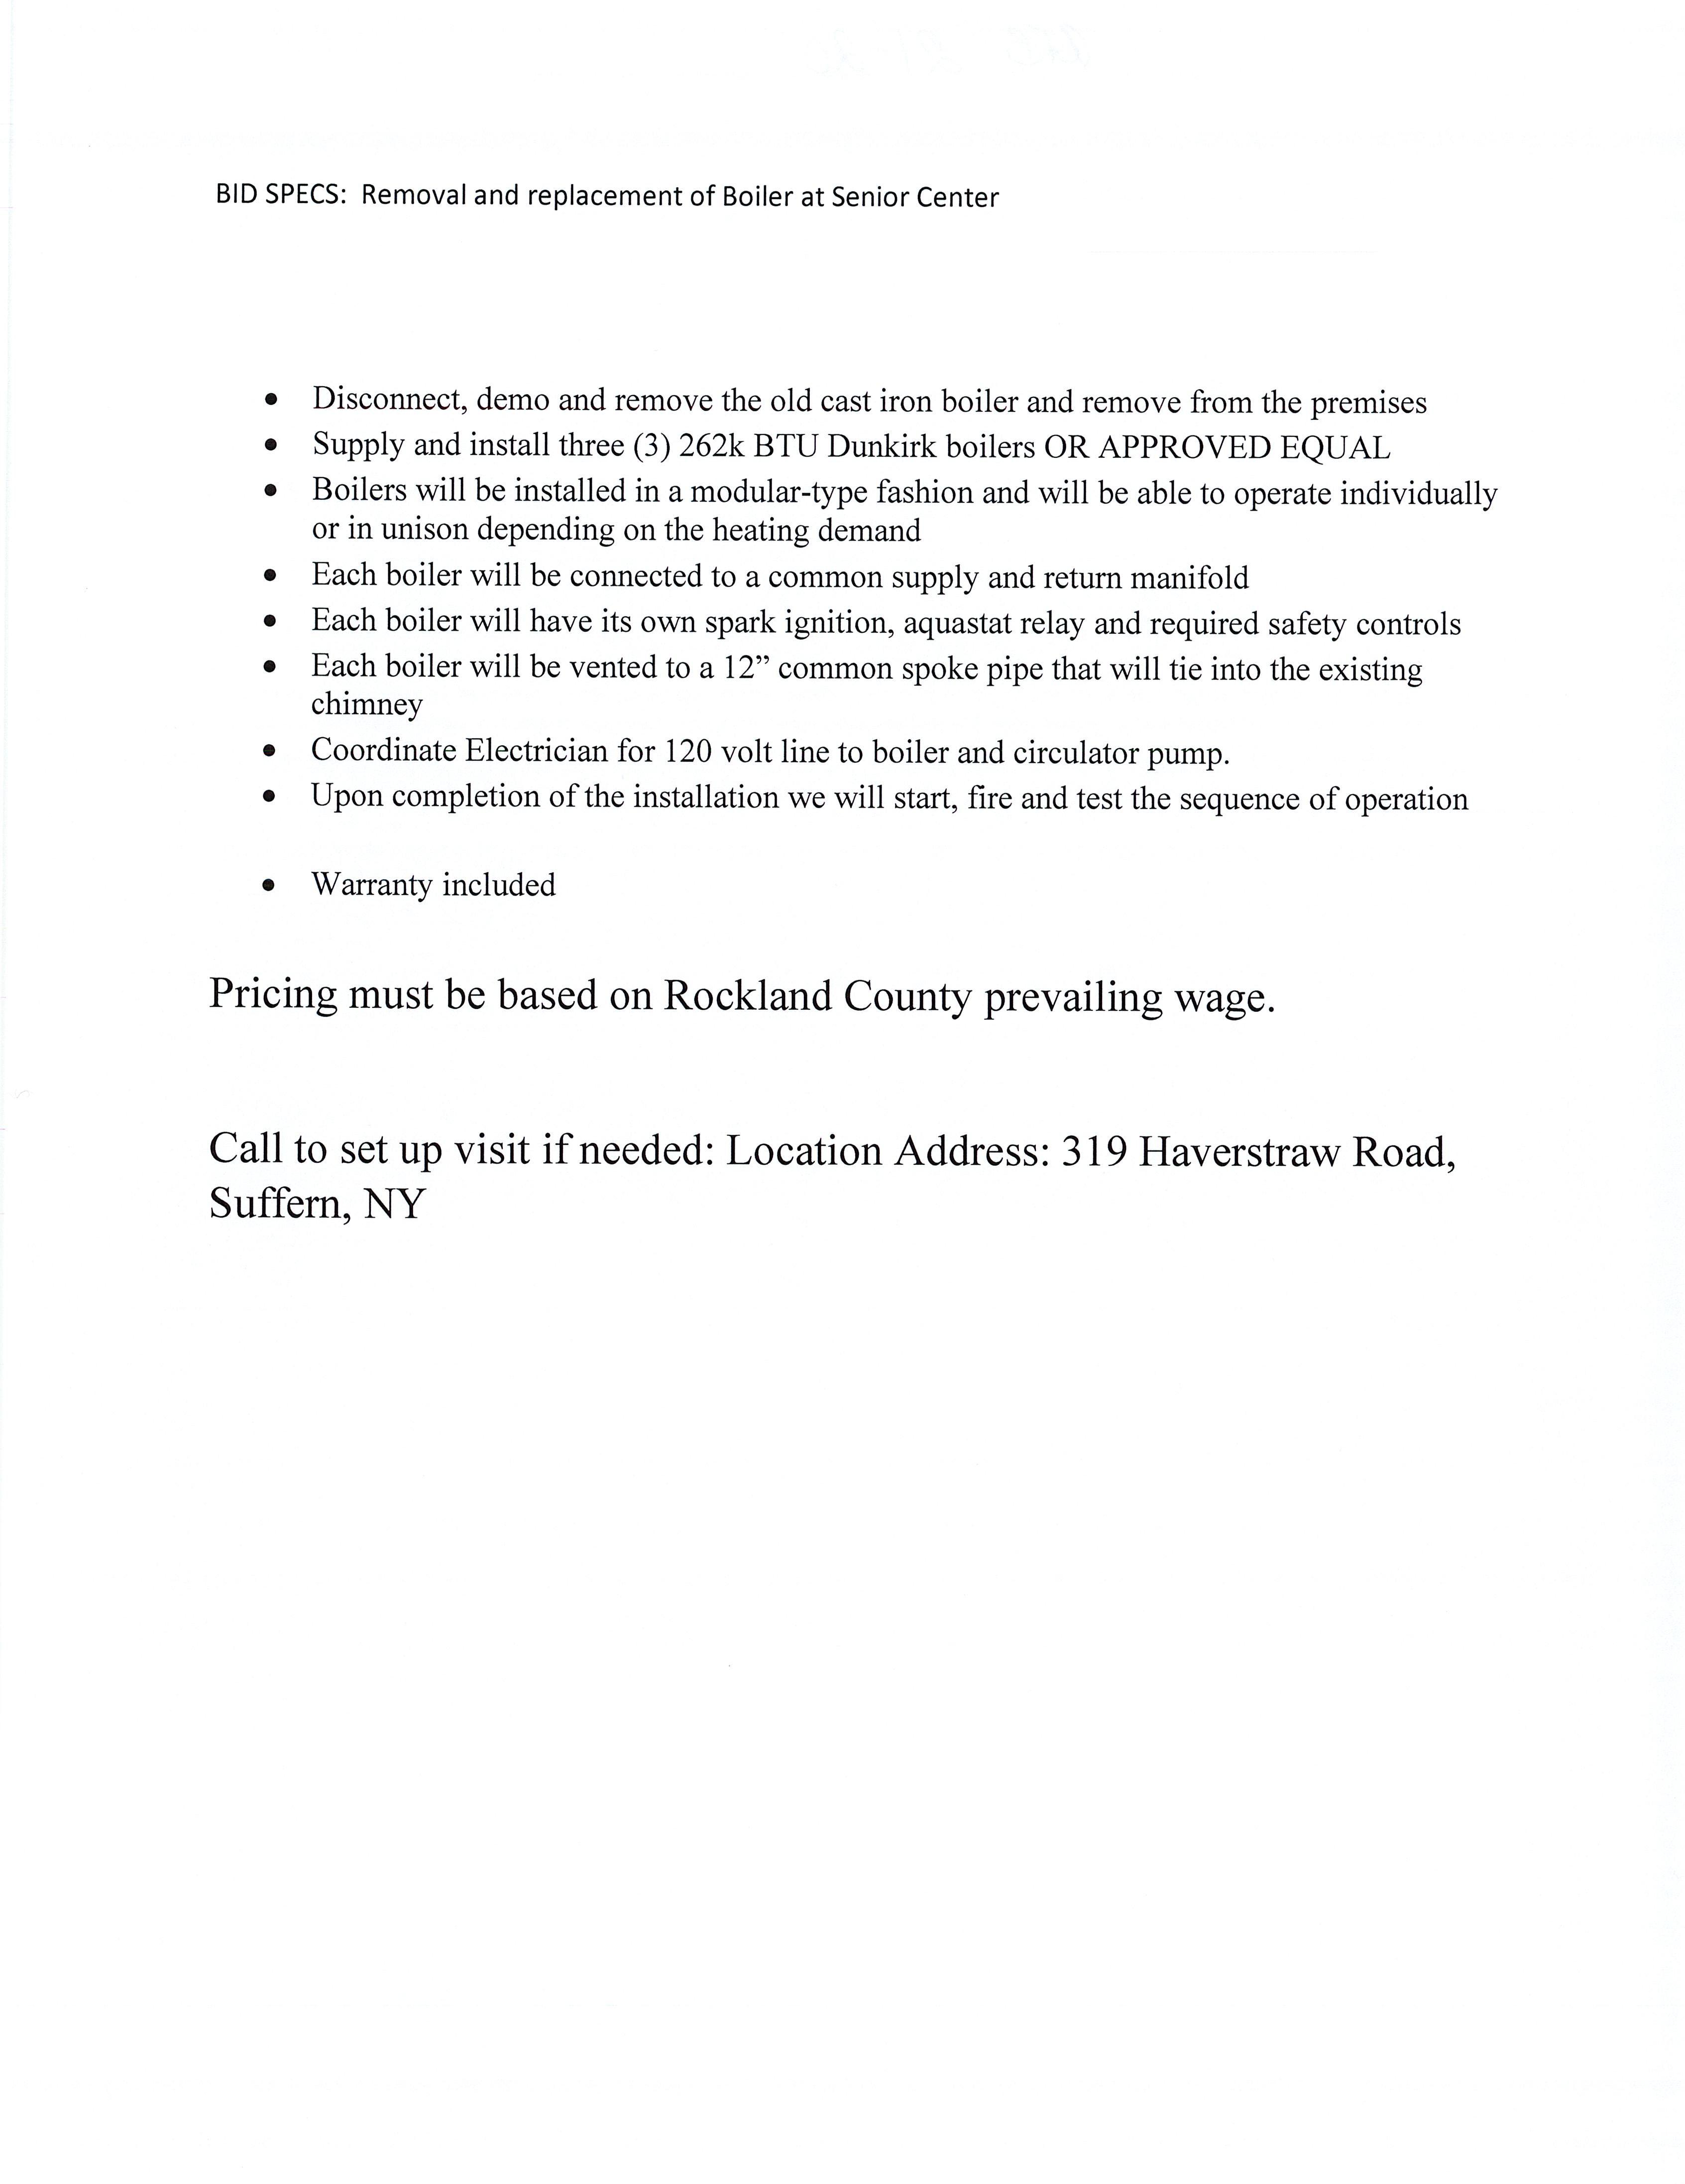

WIT N E S S E T H:

That the Town and the Contractor, for the consideration hereinafter mentioned, agree as follows:

1. CONTRACT DOCUMENTS:

a. The Contract shall consist of the Advertisement for Bids, the Information for Bidders, the Bid Form, the Schedule, Agreement including all exhibits attached thereto, the Specifications, and all Addenda (the "Contract Documents"). Any and all obligations of the Town and the Contractor are fully set forth and described therein.

- All of the above documents are intended to complement each other so that any work called for in one and not mentioned in one or more of the others is to be performed the same as if mentioned in all said documents.

c. In the event a discrepancy exists between the agreement and the attached specifications, the specifications shall be applicable.

2. WORK INCLUDED:

a. The Contractor agrees to do all the work and furnish, at his/her/its own cost and expense, all labor, materials, equipment and other facilities necessary or proper for, or incidental to Golf Course Maintenance Facility

b. All such work shall be performed in a workmanlike manner in accordance with the Contract Documents and to the satisfaction of the Town Attorney.

3. CONTRACTOR'S REPRESENTATIONS:

a. The Contractor agrees that he/she/it has carefully examined the Contract Documents and is fully informed regarding all of the conditions affecting the work to be done and labor and materials to be furnished for the completion of this contract. Contractor represents that this information was secured by personal investigation and research and not from the estimates or records of the Town, and that he/she/it will make no claim against the Town by reason of estimates, tests or representations of any officer or agent of the Town.

b. The Contractor hereby represents that the only person or persons interested as principal or principals in the bid or proposals submitted by the Contractor for this contract are named therein and that no persons other than those mentioned therein have any interest in the above mentioned proposal or in the securing of the award. Contractor further represents that this contract has been secured without any connection with any person or persons other than those named and that the proposal is in all respects fair and was prepared and secured without collusion or fraud, and that neither any officer nor employee of the Town has or shall have a financial interest in the performance of the contract or in the supplies, work or business to which it relates, or in any portion of the profits thereof.

4. CONTRACT AMOUNT:

The Town agrees to pay and the Contractor agrees to accept, in full payment for the complete performance of the work, the prices stipulated in the Bid Proposal subject to additions and deductions as provided for in the Contract Documents. Said work shall be performed in accordance with the Contract Documents without any further expense of any nature whatsoever to the Town other than the consideration set forth in this Agreement.

5. DEFINITIONS:

a. Whenever in these specifications the following terms, or pronouns in their places, are used, the intent and meaning shall be as follows:

i. "Contract" or "Contract Documents" means: The Advertisement for Bids, the Bid Form, the Schedule, the Information for Bidders, the Form of Proposal, the Agreement, the Specifications, the Summary of Work, all applicable Plans and Addenda.

ii. "Contractor" or "Prime Contractor" means: As defined in the recital to this contract.

iii. "Town Attorney” means: The Town Attorney of the Town of
Ramapo and his/her/its authorized representatives or inspectors.
iv. Specifications means: The directions, provisions and requirements, together with all written agreements, made or to be made, setting forth or relating to the method and manner of performing the work, or to the quantities and qualities of material and labor to be

v. “The Work” or “The Projects” means: All of the work to be executed and finished by the Contractor under the terms of the Contract.

vi. "Town" or "Owner" means: The Town of Ramapo as defined herein.
Attorney that sufficient cause exists to justify such action, and after giving the Contractor seven (7) days written notice, may, without prejudice to any other right or remedy, terminate the employment of the Contractor. In such cases, no further payment shall be made to the Contractor.

6 SUB-CONTRACTS:

The Contractor shall not be permitted to Sub-contract the work hereunder.

7 INSURANCE COVERAGE:

The Contractor shall not commence work under this contract until it has obtained all insurance required under this paragraph and such insurance has been approved by the TOWN.

a. Compensation Insurance - The Contractor shall take out and maintain during the life of this contract Workers' Compensation Insurance for its employees to be assigned to the work hereunder.

b. General Liability and Property Damage Insurance - The Contractor shall take out and maintain during the life of this contract such general liability and property damage insurance as shall protect it from claims for damages for personal injury including accidental death, as well as from claims for property damage which may arise from operations under this contract. The amounts of such insurance shall be as follows:

General Liability Insurance in a General Aggregate amount not less than $1,000,000 and not less than $1,000,000 on account of any one occurrence.

The contractor shall furnish the above insurance to the TOWN and shall also name the TOWN as an additional insured of said policies.

The certificate of insurance shall provide that, in the event that the insurance is cancelled prior to the expiration date thereof, the issuing insurer shall mail to the Town of Ramapo at least ten (10) days written notice.

c. Insurance Covering Special Hazards - The following special hazards shall be covered by rider and/or riders to the policy or policies herein elsewhere required to be furnished by the Contractor or by separate policies of insurance in amounts as follows: For Automobiles and Automobile Trucks - Limits shall be the same as required under General Liability Insurance as hereinbefore specified.

d. Defense of Action or Suits - Neither the TOWN nor any of its officers or agents shall in any manner be answerable or responsible for any loss or damages that may happen to the work, or to any part or parts thereof, or to any materials, equipment or other property that may be used therein, or placed upon the ground, during the progress of the work. Neither the TOWN nor any of its officers or agents shall be in any manner answerable or responsible for any injury done, or damages or compensation required to be paid under any present or future law, to any person or persons whatever, whether employees of the Contractor or others, or for damages to any property, whether belonging to the Contractor or others, occurring during or resulting from the work. The Contractor shall properly guard against all injuries and damages. The Contractor shall indemnify and save harmless the TOWN, its officers, and agents against all such injuries, damages and compensation arising or resulting from causes other than the TOWN's negligence. The Contractor shall, from the commencement of work until completion and acceptance thereof, maintain General Liability Insurance in the amounts hereinbefore stated for the protection of the Contractor and the TOWN, and shall furnish duplicates of the policies to the TOWN, stamped by the insurer "Premium Paid." These policies shall be written by an insurance company or companies approved by the TOWN.

e. The Contractor shall furnish the TOWN with satisfactory proof of the insurance required.

8. HOLD HARMLESS PROVISIONS:

The Contractor, in addition to any public liability insurance obtained under this Contract, agrees to save, indemnify and hold harmless the Town of Ramapo and all of its agents, officers, servants and employees, including any consulting engineer of the Town, by reason of any claim against all suits or liability regardless of origin or nature arising out of the project by the Contractor, any Sub-contractor or material man of the Contractor, including all laborers, employees, agents, servants, and officers thereof, whether by violation or statute, law, ordinance, regulation, order or decree or common law liability and whether or not a negligent act or omission is claimed and the Contractor agrees to pay the Town for defending such suit, all costs, expenses and reasonable attorney fees incurred therein, or at the option of the Town, shall, at the Contractor's own expense, defend any and all such actions.

9. CONVICTION OF A CRIME:

If the Contractor, any officer, director or any party holding a controlling interest (defined as five (5%) percent or more, or in the case of a corporation any stockholder owning five (5%) percent or more of the outstanding shares) is convicted of a crime, excluding Class B and Unclassified Misdemeanors (as defined under the New York State Penal Law and its equivalent in any sister state or under Federal Law) related to the subject matter of this Agreement or if a related or affiliated company, partnership or corporation is convicted of a crime, excluding Class B and Unclassified Misdemeanors (as defined under the New York State Penal Law and its equivalent in any sister state or under Federal Law) related to the subject matter of this Agreement, after this Agreement is fully executed, the Town shall have the right to terminate this Agreement without penalty. An “affiliated company” as used herein means any affiliate which is a partnership, corporation, proprietorship, association or similar entity, an “affiliate” means any individual partnership, corporation, proprietorship, association or other entity (i) in which a fifty (50%) percent or greater ownership interest (as defined below) is directly or indirectly held by the proposer or any of its management personnel (as defined below) or directors, (ii) which directly or indirectly holds fifty (50%) percent or more of the ownership interest in the proposer, (iii) in which an aggregate twenty (20%) percent or greater ownership interest is directly or indirectly held by one or more shareholders (or partners or proprietors, in the case of a partnership or proprietorship) which or who in the aggregate hold a twenty (20%) percent or greater ownership interest in the proposer, or (iv) which, whether by contract or otherwise, directly or indirectly, controls, is controlled by or is under common control with the proposer. An “ownership interest” means the ownership, whether legally or beneficially, of the stock of or assets employed by a corporation, of a partnership interest in or assets employed by a partnership or of a similar interest in or assets employed by any other entity. “Management personnel” means executive officers and all other persons, whether or not officers or employees, who perform policy-making functions similar to those of executive officers.

10. NOTICE PROCEDURES:

a. Any notice from one party to the other under the Contract, shall be in writing and shall be dated by the party giving such notice, or by a duly authorized representative of such party.

b. Any such notice shall not be effective for any purpose whatsoever, unless served in the following manner; namely,

(1) If the notice is given to the Town it shall be by personal delivery thereof to the Town Attorney, or by depositing the same in the United States mails, enclosed in a sealed envelope, addressed to the Town for the attention of the said Town Attorney, postage prepaid and registered; (2) if the notice is given to the said Contractor or to his/her/its duly authorized representative, or by depositing the same in the United States mails, enclosed in a sealed envelope, addressed to the Contractor's principal place of business set forth in this Agreement, postage prepaid and registered; and (3) if the notice is given to the surety or any other person, by personal delivery to such surety or other person, or by depositing the same in the United States mails, enclosed in a sealed envelope addressed to such surety or person, at the address of such surety or person last communicated by him/her to the party giving the notice, postage prepaid and registered.

11. DECISIONS OF THE TOWN ATTORNEY’S OFFICE:

All work under this Contract shall be done to the satisfaction of the Town Attorney and the determination of the Town Attorney’s Office shall be final and binding upon all the parties hereto and such determination, in case any question shall arise, shall be a condition precedent to the right of the party of the Contractor to receive any money hereunder.

12. DISCRIMINATION AGAINST EMPLOYEES PROHIBITED:

A. The Contractor specifically agrees to the provisions of Section 296 of the Executive Law of the State of New York or any successor statute applicable which provides among other things as follows:

1. It shall be unlawful discrimination practice:

a. For an employer, because of the age, race, color or national origin of any individual, to refuse to hire or employ or to bar or to discharge from employment such individual or to discriminate against such individual in compensation or in terms, conditions or privileges of employment.

b. For a labor organization, because of the age, race, creed, color or national origin of any individual, to exclude or expel from its membership such individual or to discriminate in any way against any of its members or against any employer or any individual employed by an employer.

c. For any employer or employment agency to print or circulate or cause to be printed or circulated any statement, advertisement or publication, or to use any form of application for employment or to make any inquiry in connection with prospective employment, which expresses, directly or indirectly, any limitation, specifications or discrimination as to age, race, creed, color or national origin, unless based upon a bona fide occupational qualification.

d. For any employer, labor organization or employment agency to discharge, expel or otherwise discriminate against any person because he has opposed any practices forbidden under this article or because he has filed a complaint, testified or assisted in any proceeding under this article.

2. It shall be an unlawful discriminatory practice for an employer, labor organization, employment agency or any joint labor management committee controlling apprentice training programs:

a. To select persons for an apprentice training program registered with the State of New York on any basis other than their qualifications, as determined by objective criteria which permit review.

b. To deny to or withhold from any person because of his/her race, creed, color or national origin the right to be admitted to or participate in a guidance program, an apprenticeship training program, on-the-job training program, or other occupational training or retraining program.

c. To discriminate against any person in his/her pursuit of such programs or to discriminate against such a person in the terms, conditions or privileges of such programs because of race, creed, color or national origin.

d. To print or circulate, or cause to be printed or circulated, any statement, advertisement or publication, or to use any form of application for such programs or to make any inquiry in connection with such program which expresses, directly or indirectly, any limitation, specification or discrimination as to race, creed, color or national origin, or any intent to make any such limitation, specification or discrimination, unless based on a bona fide occupational qualification.

13. CONTRACT INCLUDES ALL APPLICABLE LAWS:

All work covered by this Contract shall comply with Local ordinances and such other statutory provisions and regulations as pertain to this class of work. All such statutes, Rules, Regulations, Ordinances and Provisions are to be considered as much a part of this Contract as if repeated herein or attached hereto. The Laws of the State of New York shall be deemed operable with respect to all provisions of this Contract.

14. TOWN EXEMPT FROM TAXES:

The Contractor shall pay all taxes now or hereafter imposed in any fashion under this Contract, it being understood that in no case shall any tax be borne by the Town.

15. ASSIGNMENTS PROHIBIED:

The Contractor is prohibited from assigning, transferring, conveying, subletting or disposing of this Contract, or of any part thereof, or any payment to become due there under, or of his/her/its right, title or interest therein, or his/her/its power to execute such contract, to any other person or entity without the previous consent in writing to the Town. In any instance where the Contractor fails to comply with this clause, the Town may immediately declare the Contract to be breached.

16. SECTION 103-A, GENERAL MUNICIPAL LAW:

a. The Contractor hereby agrees to the provisions of Section 103-A of the General Municipal Law of the State of New York, or any successor statute applicable which requires that upon the refusal of a person, when called before a grand jury to testify concerning any transaction or contract had with the State, any political subdivision thereof, a public authority or with any public department, agency or official of the State or of any political subdivision thereof, or of a public authority, to sign a waiver of immunity against subsequent criminal prosecution or to answer any relevant question concerning such transaction or contract:

i. Such person, and any firm, partnership or corporation of which he or she is a member, partner, director or officer shall be disqualified from thereafter selling to or submitting bids to or receiving awards from or entering into any contracts with any municipal corporation or any public department, agency or official thereof, for goods, work or services for a period of five (5) years after such refusal, and

ii. Any and all contracts made with any municipal corporation or any public department, agency or official thereof, since the effective date of this law by such person, and by any firm, partnership, or corporation of which he is a member, partner, director or officer, may be cancelled or terminated by the municipal corporation without incurring any penalty or damages on account of such cancellation or termination, but any monies owing by the municipal corporation for goods delivered or work done prior to the cancellation or termination shall be paid.

17. SECTION 103-D, GENERAL MUNICIPAL LAW:

a. “By submission of this bid, each bidder and each person signing on behalf of any bidder certifies, and in the case of a joint bid each party thereto certifies as to its own organization, under penalty of perjury, that to the best of knowledge and belief:

- The prices in this bid have been arrived at independently without collusion, consultation, communication, or agreement, for the purpose of restricting competition, as to any matter relating to such prices with any other bidder or with any competitor;

- Unless otherwise required by law, the prices which have been quoted in this bid have not been knowingly disclosed by the bidder and will not knowingly be disclosed by the bidder prior to opening, directly or indirectly, to any other bidder or to any competitor; and

3. No attempt has been made or will be made by the bidder to induce any other person, partnership or corporation to submit or not to submit a bid for the purpose of restricting competition.”

18. CORPORATE RESOLUTION OF CONTRACTOR:

Attached to this Contract there shall be a certified copy of a corporate resolution of a contractor corporation authorizing the execution of this Contract and all certifications contained herein. If Contractor is a corporation, such resolution shall become a part of this Contract.

19. BUSINESS CORPORATION LAW:

At the time of the execution of this Contract, the Contractor shall submit a copy of its Certificate of Incorporation and if the Contractor is not a New York corporation, its Certificate of Authorization to do business in New York demonstrating that it is fully qualified to do business in New York verifying that Contractor is licensed to do business in the State of New York, and, is fully qualified under the Business Corporation Law (if the Contractor is a corporation).

20. ENTIRE CONTRACT INCLUDED IN DOCUMENTS:

It is understood that this Agreement and the Documents made a part hereof by its terms contains the entire Contract and that no verbal statements, conditions or representations shall be considered binding or effective.

21. DELIVERY OF COROLLARY DOCUMENTS:

Each party agrees to execute and deliver all other documents and instruments required under this Contract or necessary to the performance thereof.

22. COMMENCEMENT OF WORK:
The Contractor further agrees that he/she/it will begin the work within five (5) days of the notice from the Town to commence work.

23. JURISDICTION

Contractor consents to the jurisdiction of the courts of the State of New York for any and all disputes that may arise pursuant to this agreement.

TOTAL PRICING

REMOVE AND REPLACE BOILER AT SENIOR CENTER

$_________________________________________________________

IN WORDS ______________________________________________

PART IV

AGREEMENT

THIS AGREEMENT made and entered into the day of , 2021
by and between ,
a corporation organized under the laws of the State of , with its principal offices located at ,

herein after referred to as the "Contractor" and

TOWN OF RAMAPO, a municipal corporation of the State of New York, with its offices located at No. 237 Route 59, Suffern, New York 10901, hereinafter referred to as the "Town" or "Owner".

IN WITNESS WHEREOF, the parties hereto have caused this instrument to be signed by their corporate officers and have caused their corporate seals to be affixed hereto.

CONTRACTOR

DATE:______________________
By:

Print Name & Title

TOWN OF RAMAPO
DATE:_______________________
By:
MICHAEL SPECHT
SUPERVISOR

State of )
) SS:
County of )

On the ________day of ____________________in the year 20______, before me, the undersigned, a Notary Public in and for said State, personally appeared ___________________________________________, personally known to me or proved to me on the basis of satisfactory evidence to be the individual whose name is subscribed to the within instrument and acknowledged to me that he/she executed the same in his/her capacity, and that by his/her signature on the instrument, the individual, or the person upon behalf of which the individual(s) acted, executed the instrument.

________________________
Notary Public

State of New York )
) SS:
County of Rockland )

On the _______day of ______________________in the year 20______, before me, the undersigned, a Notary Public in a for said State, personally appeared MICHAEL SPECHT, personally known to me or proved to me on the basis of satisfactory evidence to be the individual whose name is subscribed to the within instrument and acknowledged to m that he executed the same in his capacity, and that by his signature on the instrument, the individual, or the person upon behalf of which the individual acted, executed the instrument.

________________________
Notary Public

