SECTION 275319

DISTRIBUTED ANTENNA SYSTEM (DAS)

*****************************************************************************************************************************

**NOTE TO SPECIFIER**

*Use this Specification Section for Mail Processing Facilities.*

***This is a Type 3 Specification with primarily required text; therefore, most of the text cannot be edited, but there is editable text which is noted within the Section with a “Note to Specifier.” Do not revise the required paragraphs without an approved Deviation from USPS Headquarters, Facilities Program Management, through the USPS Project Manager.***

*For Design/Build projects, do not delete the Notes to Specifier in this Section so that they may be available to Design/Build entity when preparing the Construction Documents.*

*For the Design/Build entity, this specification is intended as a guide for the Architect/Engineer preparing the Construction Documents.*

*The MPF specifications may also be used for Design/Bid/Build projects. In either case, it is the responsibility of the design professional to edit the Specifications Sections as appropriate for the project.*

*Text shown in brackets must be modified as needed for project specific requirements.* *See the “Using the USPS Guide Specifications” document in Folder C for more information.*

*The last date that USPS revised this standard specification section occurs in two places, at the end of this section and in the Table of Contents. If the date in this section matches the date in the Table of Contents, then you are using the latest version. Do not delete or revise the “last revised” date at the end of the section during the development of the Project Manual.*

*The footer in this section should be edited to replace the text, “USPS MPF SPECIFICATION” with the project name, and the blank date in the center should be replaced with the submission date, for interim design reviews, or the issue date of the completed Project Manual.*

******************************************************************************************************************************

1. GENERAL
   1. SUMMARY

****************************************************************************************************************************

**NOTE TO SPECIFIER**

Modify Paragraphs A, B, and C to coordinate with other sections in the project.

****************************************************************************************************************************

* + 1. This specification describes the technical and performance criteria for deploying a Neutral-Host Basic Distributed Antenna System (DAS) capable of supporting USPS Networks and subsequent enhancement to support Wireless Service Providers (WSP) for Cellular Telephones and/or Land Mobile Radio systems (LMR). The DAS components specified in this document include:
       1. Donor Antennas.
       2. Coverage Antennas.
       3. Coax Cable.
       4. Coax Connectors.
       5. Splitters.
       6. Combiners.
       7. Couplers.
       8. Fiber-Optic: Cable, Connectors and Jumpers.
       9. Bi-Directional Amplifiers (BDA).
       10. Fiber-Optic: Master Unit and Remote Units.
    2. Related Documents
       1. The Contract Documents, as defined in Section 011000 - Summary of Work, apply to the Work of this Section.
       2. USPS Structured Cabling System Best Practices, 01 October, 2022.
       3. Additional requirements and information necessary to complete the Work of this Section may be found in other Documents.
    3. Related Sections: Refer to the following sections for additional requirements for the Distributed Antenna System (DAS).
       1. Section 078400 – Fire stopping.
       2. Section 260500 – Common Work Results for Electrical.
       3. Section 270500 – Common Work Results for Communications.
       4. Section 271100 – Communications Equipment Room Fittings.
       5. Section 271300 – Communications Backbone Cabling.
       6. Section 271500 – Communications Horizontal Cabling.
  1. SYSTEM DESCRIPTION
     1. Services: Upon commissioning, the DAS shall provide coverage for the WSPs listed below on all frequencies currently being used by the designated WSPs and PSN in the given market.
        1. AT&T Wireless.
        2. T-Mobile.
        3. Verizon.
     2. Expansion: Without replacing the Passive DAS Infrastructure, the DAS shall have expansion capabilities to support the following WSP frequencies deployed in a SISO antenna environment. Any additional Components required for system expansion shall comply with all specifications of this Section.

|  |  |  |  |  |
| --- | --- | --- | --- | --- |
| Technology | MS/UE TX Power | Maximum BTS received power | Minimum path loss |  |
| GSM900 | +33 dBm | -26 dBm/200 kHz | 59 dB | Adj.- channel |
|  | +5 dBm | -40 dBm/200 kHz |  | Co-channel |
| DCS1800 | +36 dBm | -35 dBm/200 kHz | 71 dB | Adj.- channel |
|  | 0 dBm | -40 dBm/200 kHz |  | Co-channel |
| 3G850 | +24 dBm | -52 dBm/3.84 MHz | 76 dB | Adj.- channel |
|  | -50 dBm | -73 dBm/3.84 MHz |  | Co-channel |
| 3G2100 | +24 dBm | -52 dBm/3.84 MHz | 76 dB | Adj.- channel |
|  | -50 dBm | -73 dBm/3.84 MHz |  | Co-channel |
| 3GPP LTE | +24 dBm | -52 dBm/3.84 MHz | 76 dB | Adj.- channel |
|  | -50 dBm | -73 dBm/3.84 MHz |  | Co-channel |

* + 1. The contractor shall propose and deploy a DAS system capable of receiving WSP approval for interconnection to the WSPs’ macro networks.
    2. The contractor shall propose and deploy a DAS system capable of receiving approval of the USPS.
    3. Broadband Active Distribution: Single-mode fiber-optic cable will be used for Active distribution. In-line amplifiers are not allowed.
    4. Network Management:
       1. NMS: The DAS shall have a Network Management System (NMS) capable of alarm, monitor, configuration, and control of all Active Components.
       2. SNMP Integration: The DAS NMS shall be capable of integration with 3rd party SNMP based NMS products for alarm purposes and provide alarming information.
  1. ALTERNATIVES
     1. No alternative component(s) shall be accepted as equal to the components and manufacturers specified in this document unless the Contractor proves that the alternative component(s) are of equal or superior specifications and quality, and that they have been used in similar projects of size and complexity for no less than 3-years. The following information shall be required for each alternative component with submittal of the bid response:
        1. Passive Components:
           1. Product samples
           2. Detailed product specifications
           3. Independent test results verifying the product specifications
           4. Written documentation from the manufacturer guaranteeing that the alternative component(s) shall remain available for new purchase for a period of 7-years from the date of system acceptance.
        2. Active Components:
           1. Hardware and software manuals
           2. Detailed product specifications
           3. Mean Time Between Failure (MTBF) data for each Active Component
           4. Independent test results verifying the product specifications
           5. Written documentation from the manufacturer guaranteeing that the alternative component(s) shall be supported for a period of 7-years from the date of system acceptance.
           6. For Active Components serving the WSPs, written documentation from the WSPs that the alternative component(s) are approved for use within the WSP’s network and that interconnection of the DAS to the WSP’s network will not be withheld due to the alternative component being used in the DAS.
  2. CODES, STANDARDS AND CERTIFICATIONS
     1. All work, including but not limited to cabling, pathways, support structures, wiring, equipment, installation, workmanship, maintenance and testing shall comply with the latest editions of the National Electrical Code, National Electrical Safety Code, all applicable local rules and regulations, equipment manufacturer's instructions Standard of Installation. In case of discrepancy or disagreement between the documents noted above, the contractor shall satisfy the most stringent requirements.
  3. PERFORMANCE REQUIREMENTS
     1. Measured performance of installed DAS: In addition to the coverage, power and loss specifications above, a passive DAS shall meet the following performance requirements.
        1. Return loss
           1. Return loss measured at any input port of the multi-network combiner (or any other device serving a similar function) be greater than 20 dB over the operating frequency bands.
           2. The return loss of any feeder connected to the output ports of the multi-network combiner shall be greater than 16 dB over the operating frequency bands.
        2. Passive intermodulation
           1. The passive intermodulation performance of each passive DAS segment connecting to a multi-network combiner (Measurement point 2 in Figure 5-1) shall be -140 dBc @ 2 x 43 dBm minimum.

1. PRODUCTS
   1. Preferred Vendor List
      1. Specified in Section 270500 – Common Work Results for Communications.
      2. Specified in Section 271100 – Communications Equipment Room Fittings.
      3. Specified in Section 271300 – Communications Backbone Cabling.
      4. Specified in Section 271500 – Communications Horizontal Cabling.
2. EXECUTION
   1. INSTALLATION
      1. Note that under no circumstances the following instructions to override Code of Federal Regulations (CFR). Where there is any conflict with the building codes, installation contractor must follow Code of Federal Regulations (CFR).
         1. Passive Backbone
            1. Specified in Section 271300 – Communitcations Backbone Cabling.
         2. Active Backbone
            1. Specified in Section 271300 – Communitcations Backbone Cabling.
         3. Floor Cabling
            1. Specified in Section 271500 – Communications Horizontal Cabling.
         4. RF Sweeps
            1. All RF sweeps are to be documented as per the diagram below with the cable number and also supplied in electronic format to the lead carrier for validation and acceptance.
            2. All cables are to be swept across the 820 MHz to 960 MHz and 1710 to 2170 MHz bands.

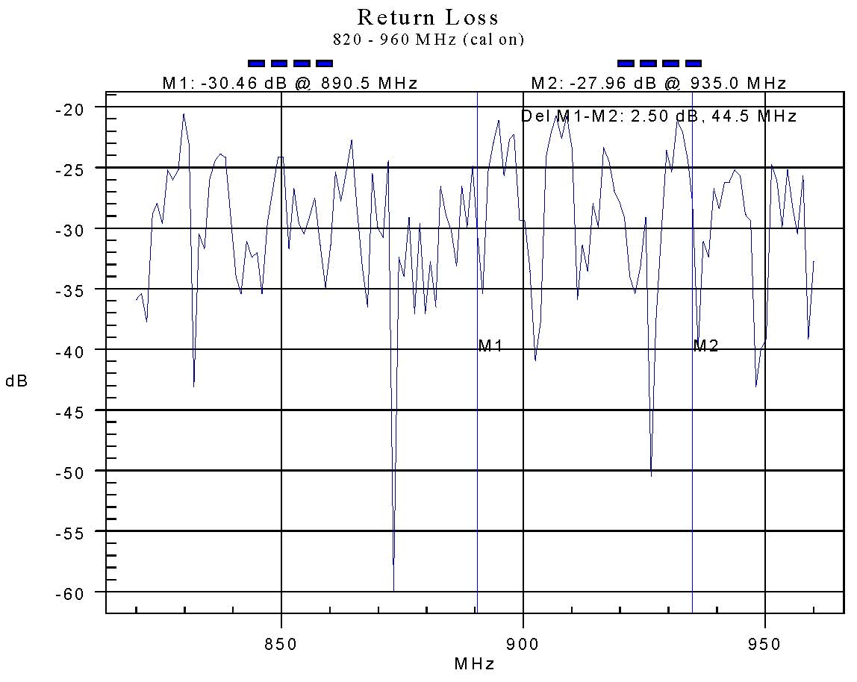

R/4/2

* 1. DOCUMENTATION
     1. All documentation shall be securely bound in a durable cover and in a form that allows easy replacement and addition of individual sheets. The design contractor shall provide two sets of all documentation supplied to the lead mobile carrier and any other sharing carriers.
     2. In addition, soft copy of all drawings and documents supplied above are to be provided on a CD. The documents shall be provided in formats compatible with Microsoft Office 2003 applications.
     3. Drawings shall be in Acrobat .PDF format. (MS Visio or AutoCAD drawing format if requested.)
     4. All scanned drawings are to be stored in JPEG Bitmap format (*.JPG) or Acrobat .PDF format.
     5. The design contractor shall provide two copies of the CD containing electronic copies of all documentation supplied.
     6. The design contractor shall provide Detailed Design Documentation and Turn-key Installation Documentation.
     7. Preliminary Design Documentation
        1. Specified in Section 270500 – Common Work Results for Communications.
     8. Detailed Design Documentation
        1. Specified in Section 270500 – Common Work Results for Communications.
     9. Installation Documentation
        1. Specified in Section 270500 – Common Work Results for Communications.
     10. Contractor/Builder initiated DAS
         1. Specified in Section 270500 – Common Work Results for Communications
     11. Insertion Loss
         1. The backbone distribution system must be checked for its insertion loss. A signal must be fed in at the base station end and the level out must be measured at the final splitting or coupling point to each floor. Where a splitter feeds more than 1 floor or there is more than 1 output from the same splitter to a floor only one output needs to be tested. The difference between the input level and the output level must be recorded as the insertion loss.
         2. All measurements for insertion loss must be tabulated as per the example below and supplied in electronic format to the lead carrier for validation and acceptance:

|  |  |  |  |  |  |
| --- | --- | --- | --- | --- | --- |
| Test Point | Frequency | Input Point | Input Power | Output Power | Insertion Loss |
| Splitter S/3/1 | 860 MHz | BC/B2/1 | +20 dBm | -3 dBm | 23 dB |
| Splitter S/11/1 | 860 MHz | BC/B2/1 | +20 dBm | -7 dBm | 27 dB |

* + 1. Passive Intermodulation Testing
       1. Passive intermodulation testing shall be carried out to determine the PIM performance of the installed DAS. The test configuration shall be in accordance with Set-up 1 of IEC 62037, using two +43 dBm test signals.
       2. Testing in one frequency band is acceptable (e.g. 900 MHz only).
       3. Test results shall be provided for reflected measurements at the following points:
       4. Each input of the multi-network combiner
       5. Each segment connected to multi-network combiner outputs (measured at the point which connects to the multi-network combiner, i.e. including cable tails).
    2. Dynamic testing
       1. Where specifications call for dynamic testing (of cable assemblies), the cable under test shall be bent through 90 degrees at its minimum bending radius, straightened, bent through 90 degrees and straightened. The worst PIM performance observed during this sequence shall be recorded.

END OF SECTION

USPS MPF Specification Last Revised: 10/1/2022